Lab Report of Artificial Intelligence
Lab 3: Logistic regression and linear regression
Student Name: David Bukedi Diela Student ID: 2018529627050

￣￣￣￣￣￣￣￣￣￣￣￣￣￣￣￣￣￣￣￣￣￣￣￣￣￣￣￣￣￣￣￣￣￣
- Objective
  - Know how Logistic regression applies in machine learning
  - Know how Linear regression applies in machine learning
- Lab content
  - Logistic regression
Logistic Regression With A Real-World Example in Python
    - usage:
Logistic Regression was used in the biological sciences in early twentieth century. It was then used in many social science applications. Logistic Regression is used when the dependent variable(target) is categorical.
For example,
-To predict whether an email is spam (1) or (0)
-Whether the tumor is malignant (1) or not (0)
Consider a scenario where we need to classify whether an email is spam or not. If we use linear regression for this problem, there is a need for setting up a threshold based on which classification can be done. Say if the actual class is malignant, predicted continuous value 0.4 and the threshold value is 0.5, the data point will be classified as not malignant which can lead to serious consequence in real time.
From this example, it can be inferred that linear regression is not suitable for classification problem. Linear regression is unbounded, and this brings logistic regression into picture. Their value strictly ranges from 0 to 1.

    - Example

Model
Output = 0 or 1
Hypothesis => Z = WX + B
hΘ(x) = sigmoid (Z)
Sigmoid Function----->
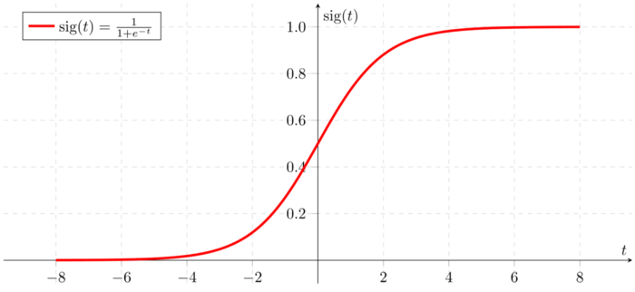

Now let’s analyze the hypothesis

Analysis of the hypothesis
The output from the hypothesis is the estimated probability. This is used to infer how confident can predicted value be actual value when given an input X. Consider the below example,
X = [x0 x1] = [1 IP-Address]
Based on the x1 value, let’s say we obtained the estimated probability to be 0.8. This tells that there is 80% chance that an email will be spam.
Mathematically this can be written as,
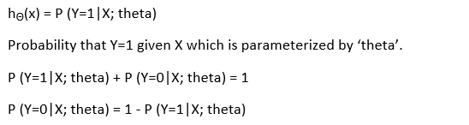

This justifies the name ‘logistic regression’. Data is fit into linear regression model, which then be acted upon by a logistic function predicting the target categorical dependent variable.
There is many type of Logistic regression (Binary Logistic regression,Multinomial Logistic regression,Ordinal Logistic regression) but for this demonstration, we will use binomial Logistic regression.

Decision Boundary

To predict which class a data belongs, a threshold can be set. Based upon this threshold, the obtained estimated probability is classified into classes.
Say, if predicted_value ≥ 0.5, then classify email as spam else as not spam.
Decision boundary can be linear or non-linear. Polynomial order can be increased to get complex decision boundary.

Cost Function

The cost function used for linear regression algorithm cannot be used for logistic because Linear regression uses mean squared error as its cost function. If this is used for logistic regression, then it will be a non-convex function of parameters (theta). Gradient descent will converge into global minimum only if the function is convex.

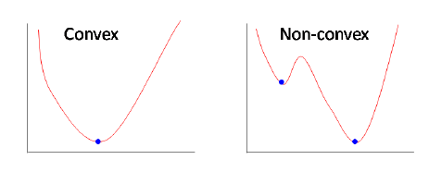
Why do we use this cost function?----->
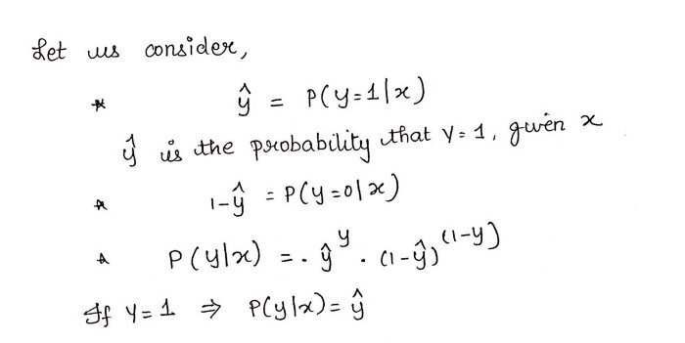
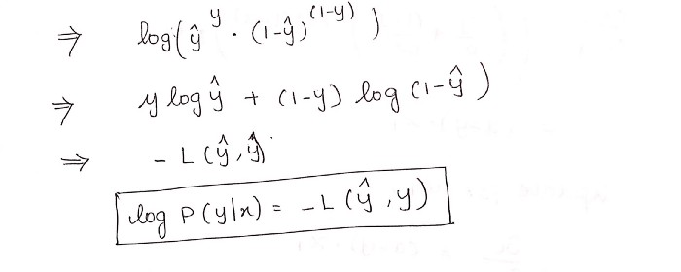
This negative function is because when we train, we need to maximize the probability by minimizing loss function. Decreasing the cost will increase the maximum likelihood assuming that samples are drawn from an identically independent distribution.
2.1.3 Code Example
Now we’ll solve a real-world problem with Logistic Regression. We have a Data set having 5 columns namely: User ID, Gender, Age, EstimatedSalary and Purchased. Now we have to build a model that can predict whether on the given parameter a person will buy a car or not.

Data Set--->
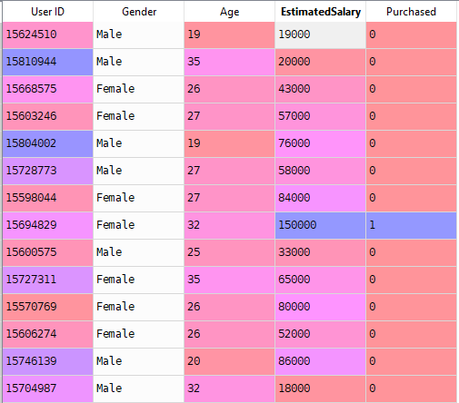

It can be found in the file “Social_Network_Ads.csv”

After Implementing the algorithm , we get an accuracy equivalent to 0.91
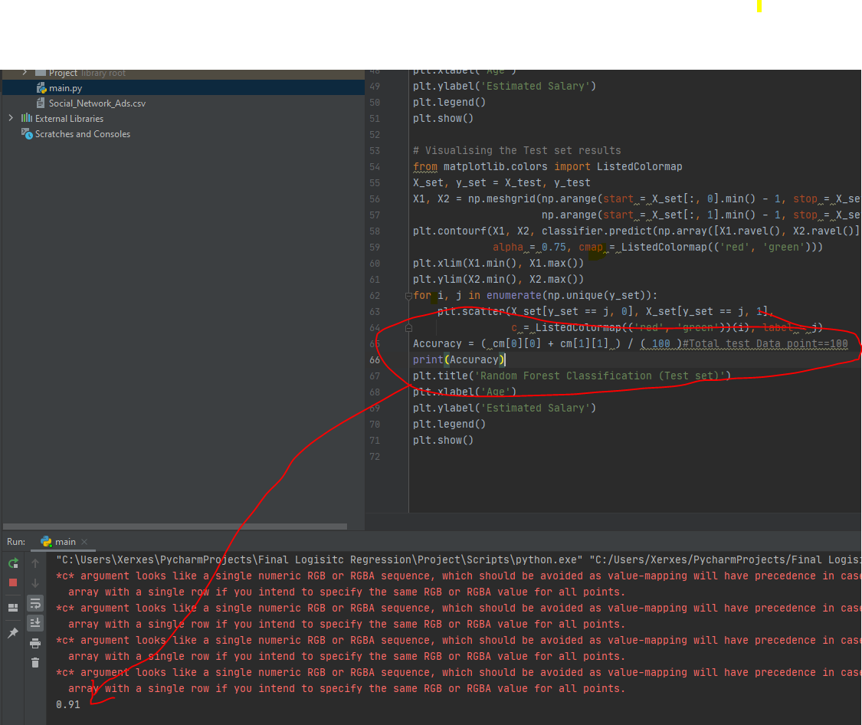
Here is the training set result:
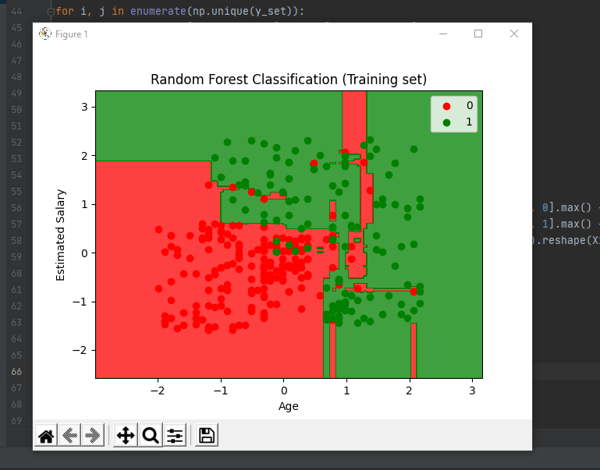

Here is the Test set result:

    - Code Implementation :

1. Importing the libraries
Here we’ll import libraries which will be needed to build the model.
import numpy as np
import matplotlib.pyplot as plt
import pandas as pd
2. Importing the Data set
We’ll import our Data set in a variable (i.e dataset) using pandas.
dataset = pd.read_csv('Social_Network_Ads.csv')
3. Splitting our Data set in Dependent and Independent variables.
In our Data set we’ll consider Age and EstimatedSalary as Independent variable and Purchased as Dependent Variable.
X = dataset.iloc[:, [2,3]].values
y = dataset.iloc[:, 4].values
4. Splitting the Data set into the Training Set and Test Set
Now we’ll split our Data set into Training Data and Test Data. Training data will be used to train our
Logistic model and Test data will be used to validate our model. We’ll use Sklearn to split our data. We’ll import train_test_split from sklearn.model_selection
from sklearn.model_selection import train_test_split
X_train, X_test, y_train, y_test = train_test_split(X, y, test_size = 0.25, random_state = 0)

5. Feature Scaling
Now we’ll do feature scaling to scale our data between 0 and 1 to get better accuracy.
Here Scaling is important because there is a huge difference between Age and EstimatedSalay.
- Import StandardScaler from sklearn.preprocessing
- Then make an instance sc_X of the object StandardScaler
- Then fit and transform X_train and transform X_test
from sklearn.preprocessing import StandardScaler
sc_X = StandardScaler()
X_train = sc_X.fit_transform(X_train)
X_test = sc_X.transform(X_test)
6. Fitting Logistic Regression to the Training Set
Now we’ll build our classifier (Logistic).
- Import LogisticRegression from sklearn.linear_model
- Make an instance classifier of the object LogisticRegression and give
random_state = 0 to get the same result every time.
- Now use this classifier to fit X_train and y_train
from sklearn.linear_model import LogisticRegression
classifier = LogisticRegression(random_state=0)
classifier.fit(X_train, y_train)
Cheers!! After executing the above command you’ll have a classifier that can predict whether a person will buy a car or not.
Now use the classifier to make the prediction for the Test Data set and find the accuracy using Confusion matrix.
7. Predicting the Test set results
y_pred = classifier.predict(X_test)
Now we can use y_test (Actual Result) and y_pred ( Predicted Result) to get the accuracy of our model.
7. Making the Confusion Matrix
Using Confusion matrix we can get accuracy of our model.
from sklearn.metrics import confusion_matrix
cm = confusion_matrix(y_test, y_pred)
You’ll get a matrix cm .
Use cm to calculate accuracy as shown below:
Accuracy = ( cm[0][0] + cm[1][1] ) / ( Total test data points )
Here we are getting accuracy of %91

  - Linear regression
Linear Regression With A Real-World Example in Python
    - usage:
It is a very powerful technique and can be used to understand the factors that influence profitability. It can be used to forecast sales in the coming months by analyzing the sales data for previous months. It can also be used to gain various insights about customer behaviour. By the end of the blog we will build a model which looks like the below picture i.e, determine a line which best fits the data.
The objective of a linear regression model is to find a relationship between one or more features(independent variables) and a continuous target variable(dependent variable). When there is only feature it is called Uni-variate Linear Regression and if there are multiple features, it is called Multiple Linear Regression.
2.2.2 Example:
The Coefficients
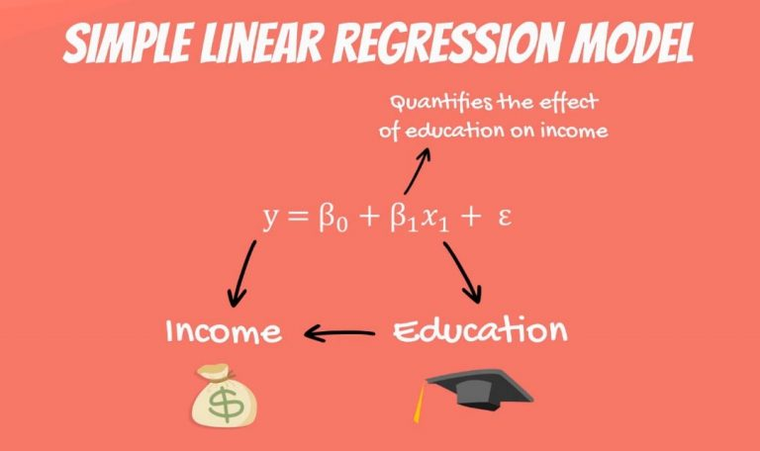
In our model, there are coefficients. β1is the coefficient that stands before the independent variable. It quantifies the effect of education on income.
If β1 is 50, then for each additional year of education, your income would grow by $50. In the USA, the number is much bigger, somewhere around 3 to 5 thousand dollars.
The Constant
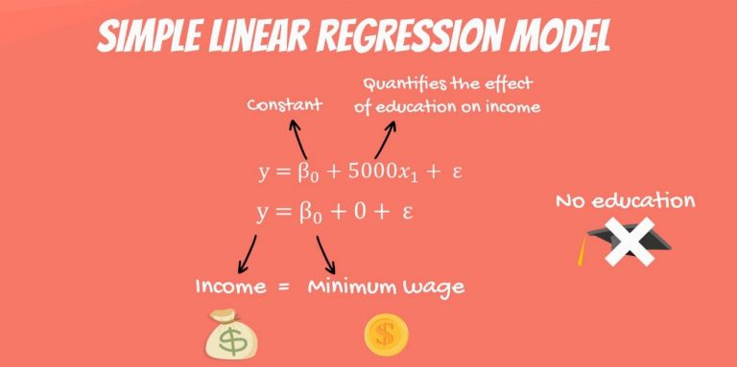
The other two components are the constant β0and the error – epsilon(ε).
In this linear regression example, you can think of the constant β0 as the minimum wage. No matter your education, if you have a job, you will get the minimum wage. This is a guaranteed amount.
So, if you never went to school and plug an education value of 0 years in the formula, what could possibly happen? Logically, the regressionwill predict that your income will be the minimum wage.
Epsilon
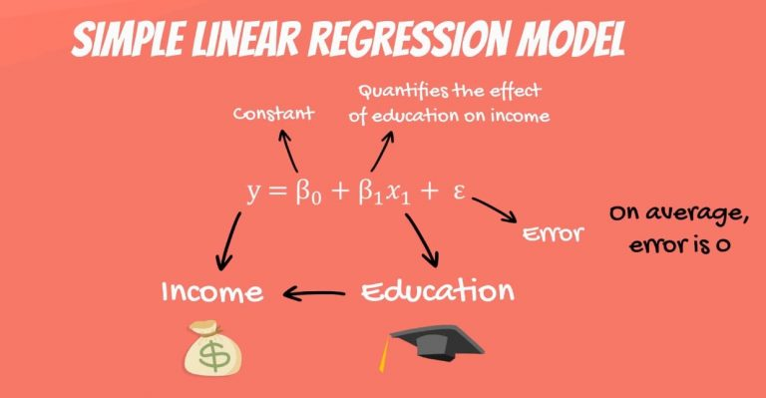
The last term is the epsilon(ε). This represents the error of estimation. The error is the actual difference between the observed income and the income the regression predicted. On average, across all observations, the error is 0.

The Linear Regression Equation

The original formula was written with Greek letters. This tells us that it was the population formula. But don’t forget that statistics (and data science) is all about sample data. In practice, we tend to use the linear regression equation.
It is simply ŷ = β0+ β1* x.

The ŷ here is referred to as y hat. Whenever we have a hat symbol, it is an estimated or predicted value.
B0 is the estimate of the regression constant β0. Whereas, b1 is the estimate of β1, and x is the sample data for the independent variable.

The Regression Line
You may have heard about the regression line, too. When we plot the data points on an x-yplane, the regression line is the best-fitting line through the data points.

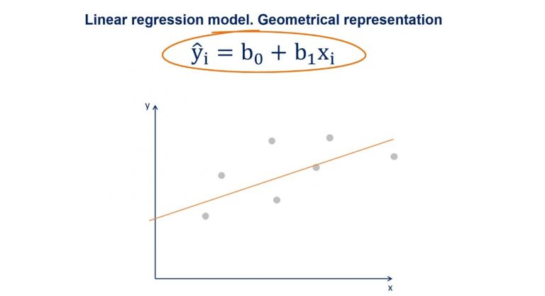
You can take a look at a plot with some data points in the picture above. We plot the line based on the regression equation.
The grey points that are scattered are the observed values. B0, as we said earlier, is a constant and is the intercept of the regression line with the y-axis.
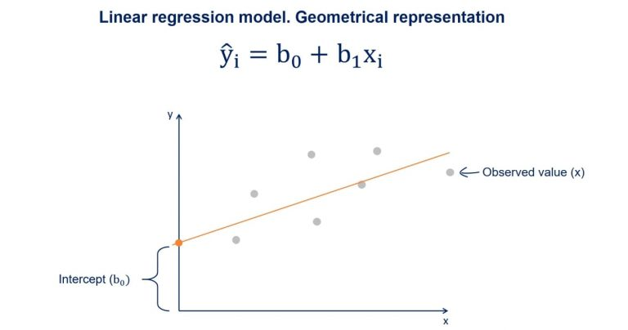
B1 is the slope of the regression line. It shows how much y changes for each unit change of x.

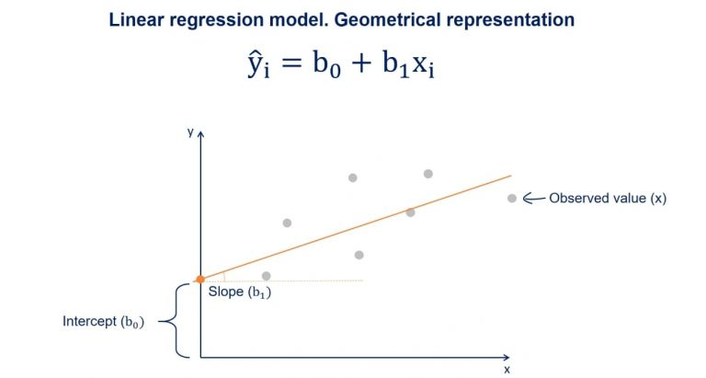

The Estimator of the Error
The distance between the observed values and the regression line is the estimator of the error term epsilon. Its point estimate is called residual
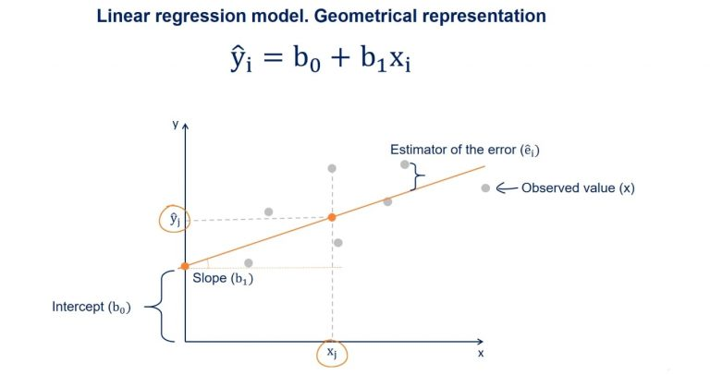

2.2.3Code example:
Lets take the data of passenger vehicle sales in India. To keep things simple, lets say only one variable which is GDP of the country has impact on the sales. In reality there are more factors like auto interest loan rates etc but thats for next article. For this lets focus on linear equation of number of vehicle sold in India wrt GDP.
Sample Data
I looked at passenger vehicles sales in India year wise for last few years. Also checked GDP for each year. While looking at both the data it dawned upon me that impact of GDP in ‘current year’ will have effect on vehicle sales ‘next year’ . So whichever year GDP was less, the coming year sales was lower and when GDP increased the next year vehicle sales also increased. Hence they say preparing the data for ML analytics is more important and thats where most time needs to be spent.
Lets have equation as y = c + ax .
y = number of vehicles sold in the year
x = GDP of prior year.
We need to find c and a.
Below is table of data. I saved this data in a file called ‘vehicle_sale_data’. Please note that number of vehicles sold figure is in lakhs (1 lakh = 0.1 million).
year,GDP,4wheeler_passengar_vehicle_sale(in lakhs)
2011,6.2,26.3
2012,6.5,26.65
2013,5.48,25.03
2014,6.54,26.01
2015,7.18,27.9
2016,7.93,30.47

Model creation
We will use python to create the model. Below are the steps.
- Read the file. ‘gdp_sale’ dictionary will have key as GDP and value is sales.
def read_data() :
data = open("vehicle_sale_data" , "r")
gdp_sale = collections.OrderedDict()
for line in data.readlines()[1:] :
record = line.split(",")
gdp_sale[float(record[1])] = float(record[2].replace('\n', "")) return gdp_sale
- Calulate the step and get to new ‘c’ and ‘a’. For first time, we will pass the initial value ‘c’ and ‘a’. This function will calculate the values of new c and new a after moving one step. This function need to be called iteratively till it stablizes.
def step_cost_function_for(gdp_sale, constant, slope) :
global stepSize
diff_sum_constant = 0 # diff of sum for constant 'c' in "c + ax" equation
diff_sum_slope = 0 # diff of sum for 'a' in "c + ax" equation
gdp_for_years = list(gdp_sale.keys()) for year_gdp in gdp_for_years: # for each year's gdp in the sample data
# get the sale for given 'c' and 'a'by giving the GDP for this sample record
trg_data_sale = sale_for_data(constant, slope, year_gdp) # calculated sale for current 'c' and 'a'
a_year_sale = gdp_sale.get(year_gdp) # real sale for this record
diff_sum_slope = diff_sum_slope + ((trg_data_sale - a_year_sale) * year_gdp) # slope's (h(y) - y) * x
diff_sum_constant = diff_sum_constant + (trg_data_sale - a_year_sale) # consant's (h(y) - y) step_for_constant = (stepSize / len(gdp_sale)) * diff_sum_constant # distance to be moved by c
step_for_slope = (stepSize / len(gdp_sale)) * diff_sum_slope # distance to be moved by a
new_constant = constant - step_for_constant # new c
new_slope = slope - step_for_slope # new a return new_constant, new_slope
- Function to get the sales of vehicles provided the values of c, a and x. Used by above function for each sample data (gdp).
def sale_for_data(constant, slope, data):
return constant + slope * data # y = c + ax format
- Iteration to get optimum weights ie optimum values of c and a. It will stop if c and a both are not moving more than 0.01 in next iteration.
def get_weights(gdp_sale) :
constant = 1
slope = 1
accepted_diff = 0.01 while 1 == 1: # continue till we reach local minimum
new_constant, new_slope = step_cost_function_for(gdp_sale, constant, slope)
# if the diff is too less then lets break
if (abs(constant - new_constant) <= accepted_diff) and (abs(slope - new_slope) <= accepted_diff):
print "done. Diff is less than " + str(accepted_diff)
return new_constant, new_slope
else:
constant = new_constant
slope = new_slope
print "new values for constant and slope are " + str(new_constant) + ", " + \
str(new_slope)
- And of course the main function
def main() :
contant, slope = get_weights(read_data())
print "constant :" + contant + ", slope:" + slopeif __name__ == '__main__':
main()
I got the equation as
y (vehicles sales) = 1.43 + 3.84 * x
- x is value of GDP
So we get that the error margin is 0.01% that is 99.9% of correctness
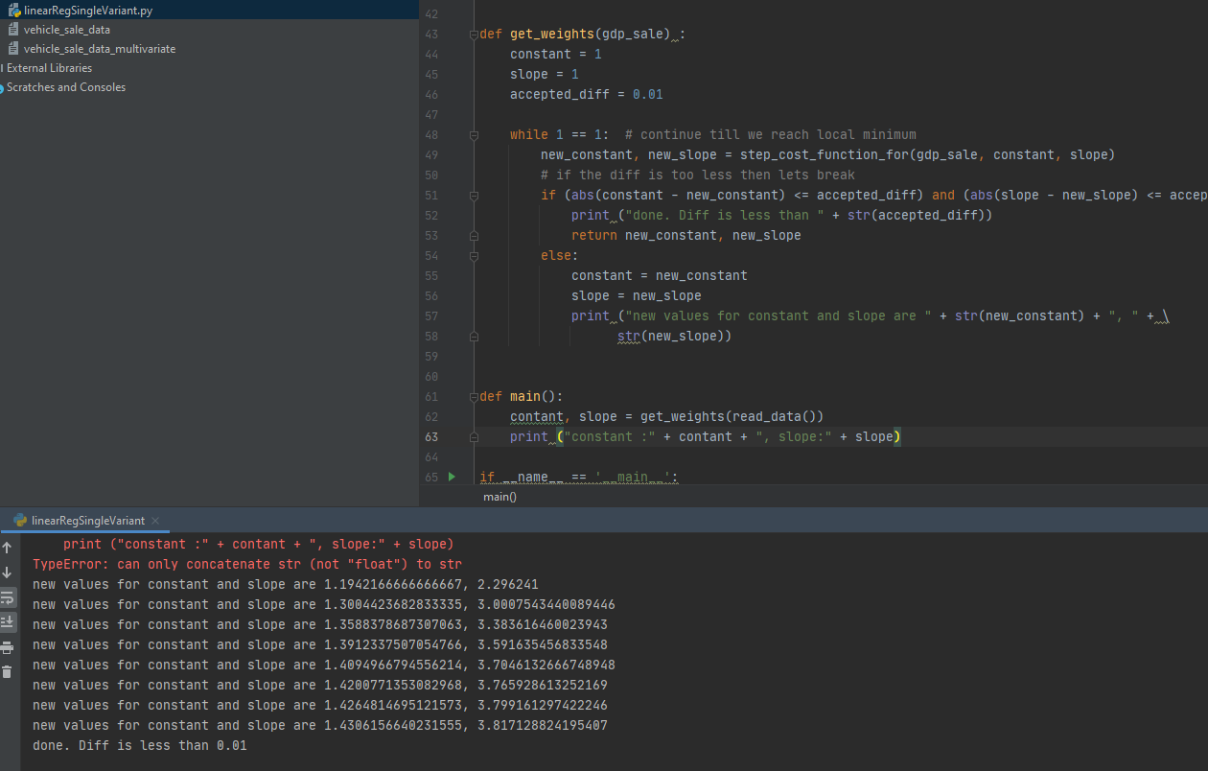
So if we have GDP as 7.5 this year then we will have passenger vehicles sales next year as — 1.43 7.5*3.84 = 30.23

- References
Github:
Logistic Regression:

- https://github.com/shivang98/Social-Network-ads-Boost
- https://github.com/llSourcell/logistic_regression
- https://github.com/mbilalzafar/fair-classification
Linear Regression:
- https://github.com/skhurana333/ml/blob/master/linearRegSingleVariant.py
Website:
Logistic Regression:
- https://blog.goodaudience.com/machine-learning-using-logistic-regression-in-python-with-code-ab3c7f5f3bed
- https://www.marktechpost.com/2019/06/12/logistic-regression-with-a-real-world-example-in-python/

Linear Regression:
- https://365datascience.com/linear-regression/
- https://towardsdatascience.com/linear-regression-using-python-b136c91bf0a2

